- Manufacucturers
- Distributors
- Payment service providers
- Web services providers
- Advertising agents
Denmah Chain of Stores
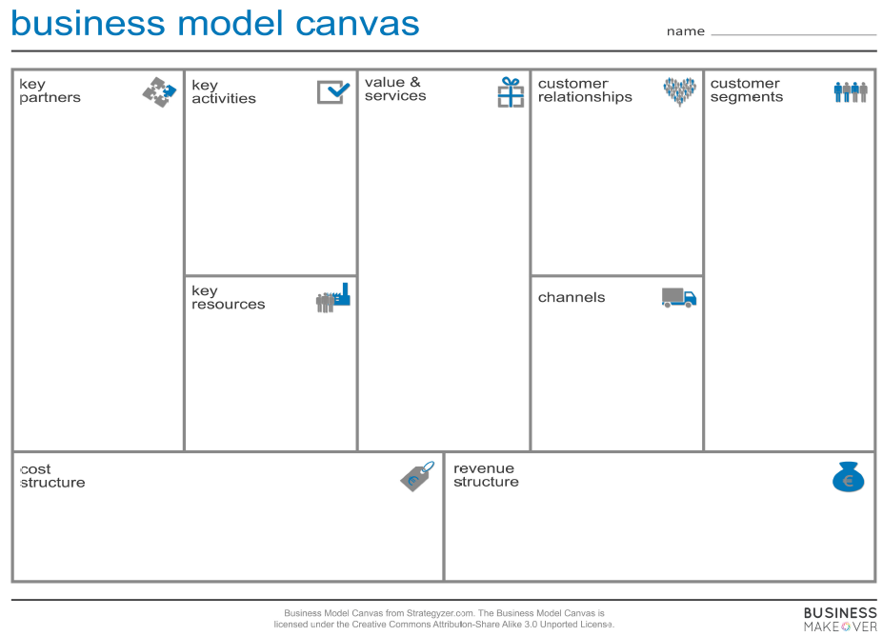
- Consumers
- Internet users

- Develop website
- Maintain website
- Marketing
- Listing of service providers
- Uploading products
- Warehousing services
- Delivery services
- Buying access to different products from different sellers
- Inform customers on new product listing
- Reduce the burden of moving to different physical stores for price or product comparison
- Online mass customization

- Manufacturers
- Website developers
- Hosting servers
- Payments services
- Website
- Social Media Platforms (whatsapp, facebook etc)
- Google ads

- Website designing and hosting
- Delivery services
- Marketing
- Warehousing services
- Commission on sales
- Promotion of certain products

